**EMTH1019 Linear Algebra and**

**Statistics for Engineers**

**Workshop 9 Solutions**

1. (a) American heads of household
   1. 1000
   2. Hardest household place to clean
   3. 1000 × 0*.*12 = 120
   4. Actual percentage could be 5% lower or 5% hihger than quoted.
   5. Between 30% and 40% of all adults think that Venetian blinds are the hardest to clean.
2. (a) Yes, if the rate increases from 4% to 6%, that i sa 50% increase in the rate : (6 − 4)*/*4 = 2*/*4 = 0*.*50 = 50%. As a percent alone, the 50% is meaningless; it does not give the actual size of the numbers involved.
   1. The phrase ”50% jump” works much more effectively at getting people’s attention than does ”2% increase”
3. (a) All assembled parts from the assembly line
   1. infinite
   2. The parts checked
   3. Categorical, categorical, numerical.
4. $\overline{x}=(\sum{x})/n$ = (1 + 2 + 1 + 3 + 2 + 1 + 5 + 3)*/*8 = 18*/*8 = 2*.*25
5. Ranked data: 4.15, 4.25, 4.25, 4.50, 4.60, 4,60, 4.75, 4.90; position of median is(*n* + 1)*/*2 = (8 + 1)*/*2 = 4*.*5, i.e. mean of 4th and 5th values in the ranked data. So, median = (4*.*50 + 4*.*60)*/*2 = 4*.*55.
6. (a) mean = ${\sum{x}}/n$ = 402*/*10 = 40*.*2
   1. ranked data: 28, 29, 33, 40, 41, 42, 44, 48, 48, 49. Position of median is(*n* + 1)*/*2 = (10 + 1)*/*2 = 5*.*5, i.e. mean of the 5th and 6th position, so median = 41.5.
   2. Mode = 48.
7. The mean is the balance point or the centre of gravity to all the data values. Since the weights of the data values on each side of ¯*x* are equal, $Σ$ (*x* − *x*¯) will give a positive amount and and an equal negative amount, thereby cancelling each other out. Algebraically:
8. (a) 9 − 2 = 7
   1. *s*2 = 8*.*5

(

c

)

*s*

=

√

*s*

2

=2

*.*

9

9.

(

a

)

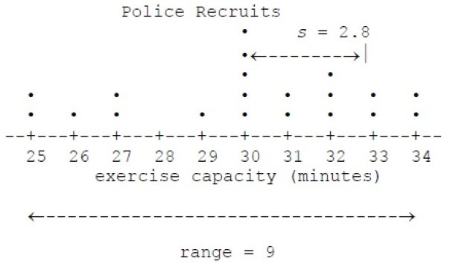

(

b

)¯

*x*

=601

*/*

20=30

*.*

05

* 1. 34 − 25 = 9
  2. 7.8.(e) 2.8.
  3. see the graph.
  4. Except for the value *x* = 30, the distribution looks rectangular. Range is a little more than 3 standard deviations.

1. (a) Ranked data: 2.6, 2.7, 3.4, 3.6, 3.7, 3.9, 4.0, 4.4, 4.8, 4.8, 4.8, 5.0, 5.1, 5.6,

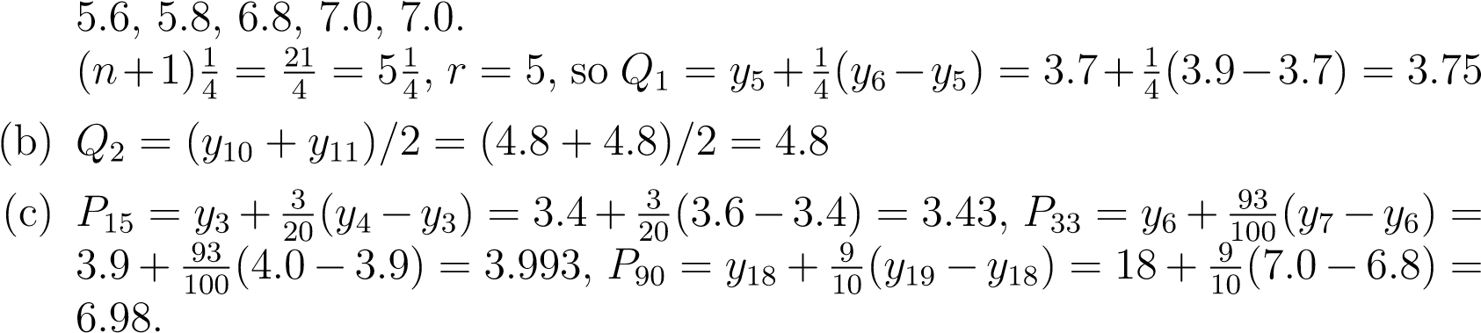

1. (a) Find
   * 1. Find *Q*2 = (4*.*0 + 4*.*0)*/*2 = 4*.*0.
     2. Find
     3. Find *P*30 = 3*.*1 + 0*.*9 ∗ 0*.*1 = 3*.*19.
     4. 5-number summary: 1*.*4*,*3*.*025*,*4*.*0*,*4*.*675*,*13*.*3

(f) 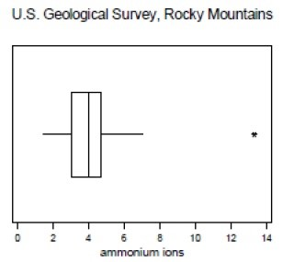

12.

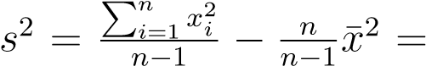22 (to 2 d.p).

√

8*.*69 (to 2 d.p.). *s* = *s*2 = 2*.*95 (to 2 d.p.)

(b) *Q*1 = 7, *Q*2 = 10, *Q*3 = 11*.*5. Five Number Summary: 4*,*7*,*10*,*11*.*5*,*13, *Range* = *Max* − *Min* = 13 − 4 = 9 and *IQR* = *Q*3 − *Q*1 = 11*.*5 − 7 = 4*.*5.

(c) 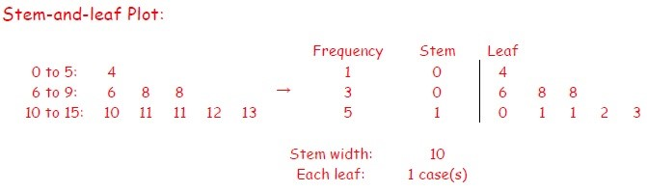

1. *Q*1 − 1*.*5*IQR* = 7 − 1*.*5(4*.*5) = 0*.*25, *Q*3 + 1*.*5*IQR* = 11*.*5 + 1*.*5(4*.*5) = 18*.*25

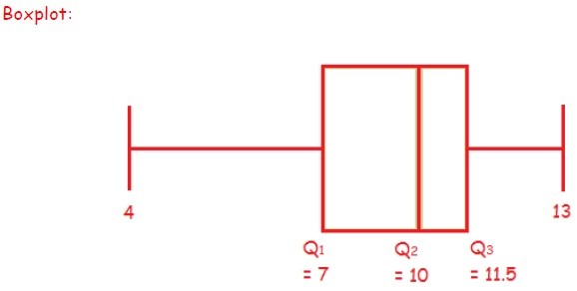

1. If we multiply each of the original data by 10 then subtract 3, this is the sameas transforming *x* into *y* by using *y* = *a* + *bx* with *a* = −3 and *b* = 10.

New sample mean: ¯*y* = *a* + *bx*¯ = −3 + 10 × 9*.*2222*...* ≈ 89*.*22 (2 d.p.)

New sample variance: 44 (2 d.p.)

New sample std: *sy* = |*b*|*sx* = 10 × 2*.*9486*...* ≈ 29*.*49 (2 d.p.) New median: *Med*(*y*) = *a* + *bMed*(*x*) = −3 + 10 × 10 = 97

New range: *R*(*y*) = |*b*|*R*(*x*) = 10 × 9 = 90

New IQR: *IQR*(*y*) = |*b*|*IQR*(*x*) = 10 × 4*.*5 = 45